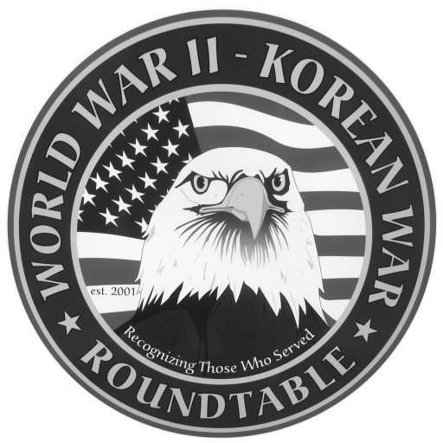 | Fairlawn Kiwanis Community Center - 3486 S. Smith Rd (off Market St.)  Fairlawn, OH 44333 - (across from City Hall and the Fire Station)

: September 24, 2009, THURSDAY, 6:45 P.M. (The 4th Thursday)

SPEAKER: Jerry Kennard, airman shot down over Italy, captured and hospitalized. Later escaped and was helped by the partisans until his recapture )
August Meeting Summary::. Dr. Joe Foley , US Navy Medical Corps, was in the Beach Battalion along with the combat engineers at the Invasions of Sicily and
Normandy (Utah Beach). His job ,aided by 8 Navy Corpsmen , was to take care of the wounded on the landing craft, on the beach and from inland. He felt that without adequate medical equipment he really wasn’t doing any good on the beach. He was told that doctors were on the beach for morale purposes. At the end of the war he encountered the seriously wounded while he was stationed at the Philadelphia Naval Hospital. He suggested that governments ought to not only report the deaths of their soldiers but also show graphically the injuries that are the consequences of war. Attendance was 91.
E-MAIL ADDRESSES: If you have an E-Mail address and wish to receive the meeting notices via E-Mail please contact Dean Smith (330 835 9895) or Ed Bollinger (330 836 6272 or.ehbollinger@netzero.net). If you change your E-mail address contact Ed.
DUES: Dues for July ’09 to August 2010 are $15 Please send them to Dan Demko at 1627 S. Cleveland Massillon Rd.. Copley, OH 44321
SPEAKERS FOR 2009: Mrs Jerri Donohue is our official “speakers” recruiter. Call Jerri at 440 546 1207 to volunteer yourself or to recommend others.
FUTURE SPEAKERS.
October 22, 2009 (4th Thursday): Don Esmond & Bill Wynne, 5th Air Force
Reconnaissance Squadron; New Guinea & Philipines plus war dog Smoky.
November 19 (3rd Thursday); Robert L. Sabetay 3rd Army, 90th Infantry Division;
N. France, Ardennes, Rhineland and Central Europe
Please complete the following and return the form with your payment to Dan Demko,
Treasurer, 1627 S. Cleveland Massillon Rd., Copley, OH 44321. Checks should be
payable to the World War II – Korean War Roundtable.

NAME:_________________________________________________________________

ADDRESS:_____________________________________ _________________ ______
Street City Zip
TELEPHONE NO. _____________________ E-MAIL_________________________
If you are a new applicant, please complete the following:

Service Branch_________________ WWII_____ Korea_____ Other____________
Do you wish to be called by the telephone committee? YES ___ or NO ___

